**LOVE STORY: NUCLEAR LOVE**

**Genre: Parody, comedy, romance**

**Setting:**

Story has two main protagonists – Donald Trump and kim Jong Un. It is a heartfelt story about love of two men and their passion for nuclear warheads.

**Message:**

Sharing is caring.

**Prelude:**

Story starts with the appearance of Kim Jong Un – he looks very sad and depressed. In next frame appears Donald Trump and he looks happy, confident and is carrying a nuclear wargead in his right hand.

**Point of no return:**

Trump immediately realises what is wrong and offers Kim his nuclear warhead.

**Climax:**

Kim Jong Un shyly accepts the warhead, and Trump is a little bit surprised by Kim’s shyness.

**Fade out:**

Both men can feel a romance in the air, the pressure has cleared and they have fallen in deep love with each other, comaprable only of their love for nuclear warheads.

**Main Character: Trump – 8 poses**

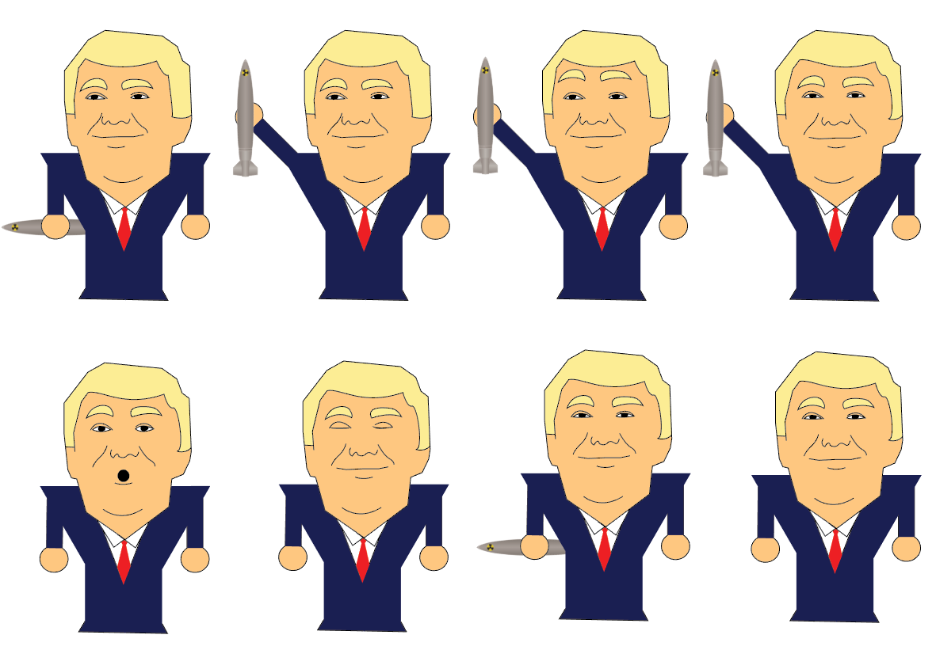

**Main Character: Kim Jong Un - 7 poses**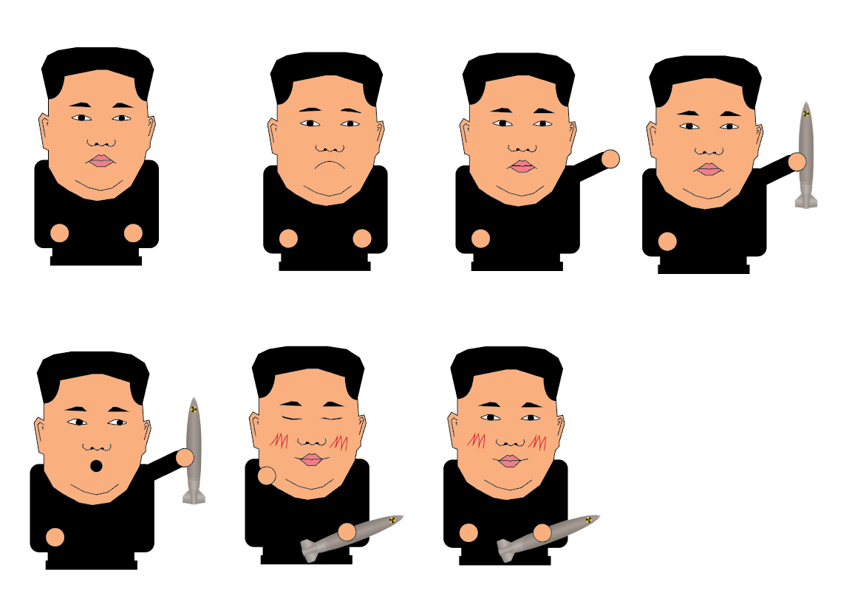

**Story board:**

